**Task 5**

**Task descrition:** Create two storage accounts and containers or objects with files in it and move files between them in your preferred cloud.

* I did this task in AWS console.

Step 1: create two buckets in amazon S3.

My first bucket name 🡪t5buck1

Second bucket name 🡪t5buck2.

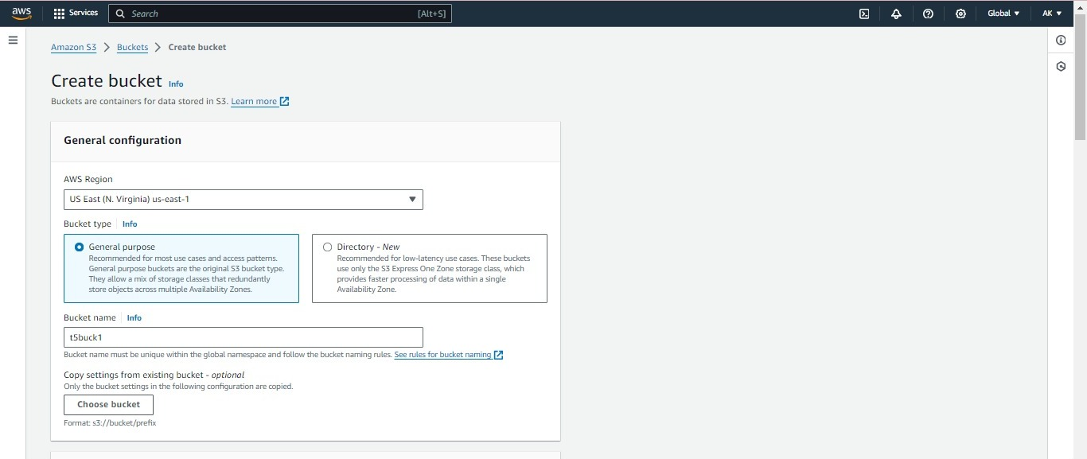

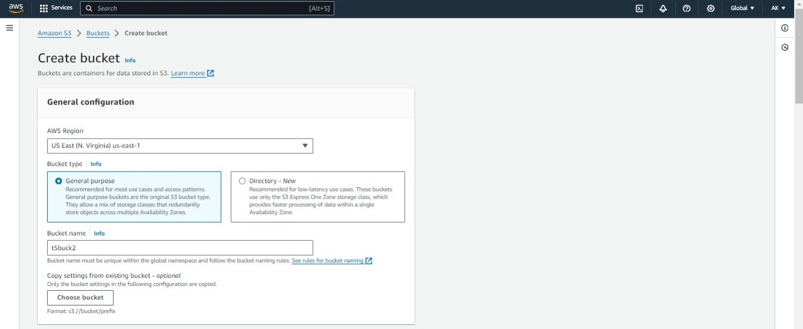

Step 2: Upload a file in t5buck1.

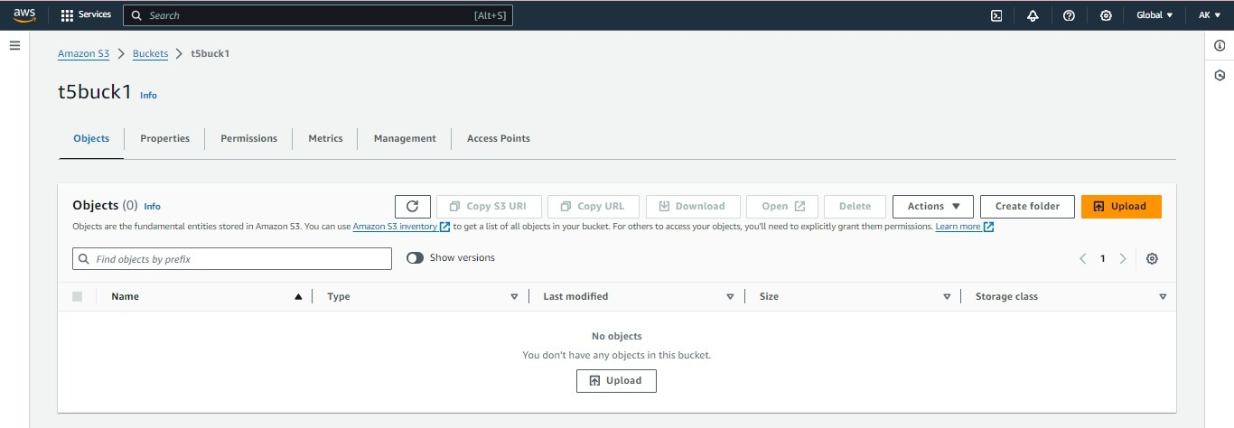

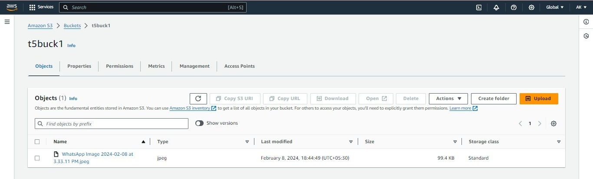

Step 3: click on 🡪“Actions” 🡪”move”.

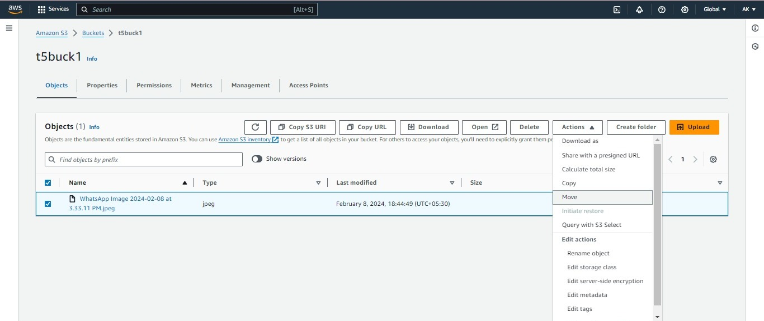

Step 4: Now select your destination in this window.

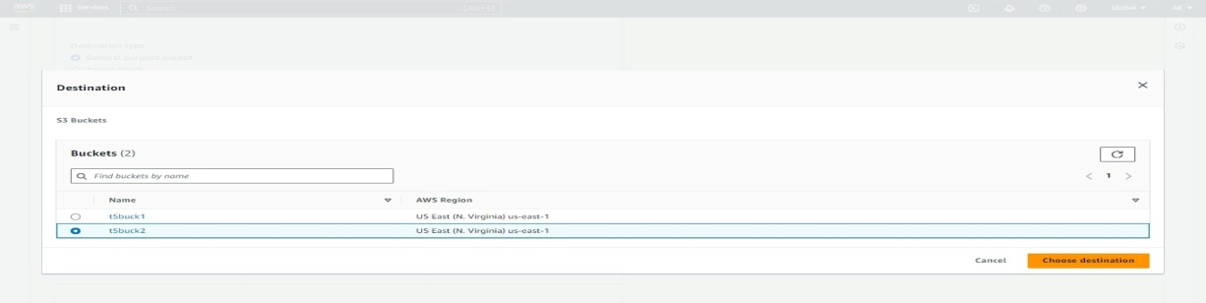

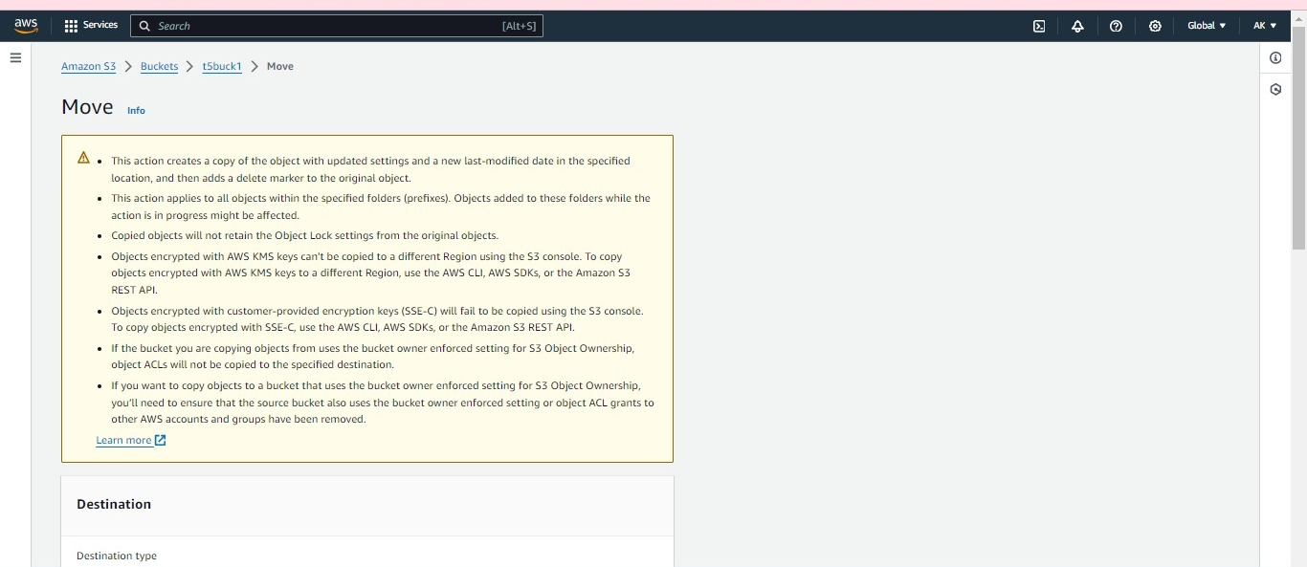

Step 5: Browse your S3

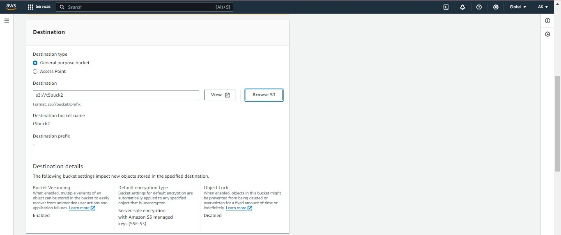

Step 6: click on move.

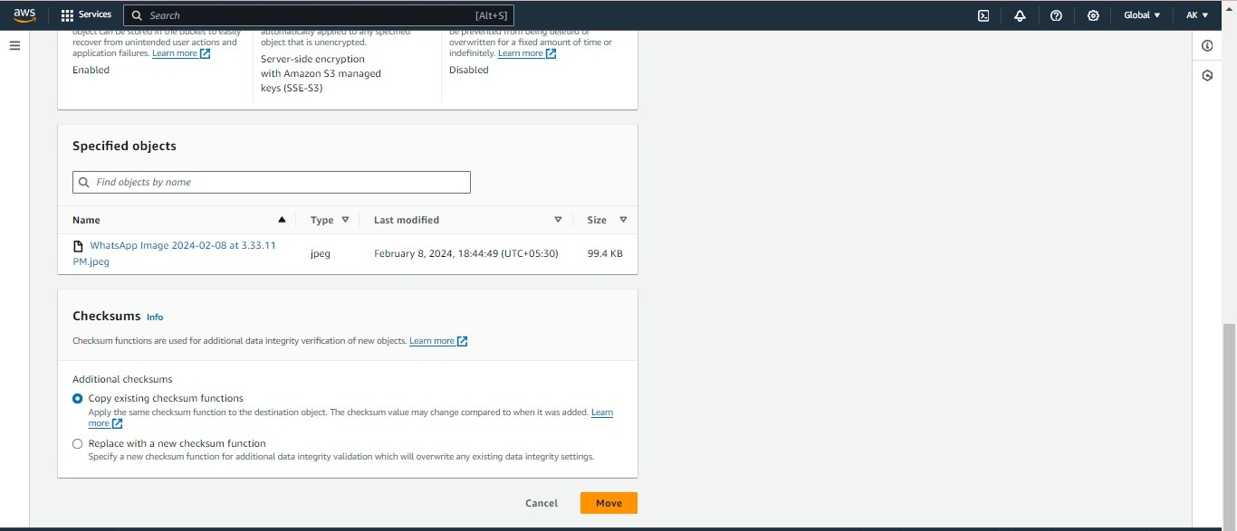

Step 7: The file is uploaded in my second bucket and my original bucket in t5buck1 is erased.

